BASS AND TREBLE EQUALISER (Implemented using Python)

(Comprehensive Project Report)

Contents

- Abstract
2. An Overview of the Topic
3. Proposed Methodology
4. Brief Description of Code
5. MatLab Code
6. Observations
7. Results andConclusions
8. References

ABSTRACT:

Audio equalization is a vast and active research area. Audio equalizers are commonly used to adding, removing or modifying frequencies from speciﬁc audio signals. An equalizer is a system designed to change the characteristics of the tone of a given input audio signal on purpose by modifying the frequency response through an assortment of ﬁlters until the desired frequency spectrum is achieved. Equalizers are used in music production to adjust the timbre of individual instruments and voices by adjusting their frequency content and to fit individual instruments within the overall frequency spectrum of the mix.

OVERVIEW:

Bass and Treble are at the two ends of the frequency spectrum. By giving these bass and treble eﬀects we can modify the original music.

Bass (dB)
Bass is characterized by a very low-pitched sound and is the lowest tone that is registered in musical instruments and the lowest singing voice range. The amount of gain (amplification above 0 dB or attenuation below 0 dB) to bass (low) frequencies. It is mostly used to amplify the frequencies at the lower audible range, the maximum of which is 300 kHz.
Treble (dB)
Treble means the highest part in a composition that has three parts which came from the Latin “triplus.” It is characterized by a very high pitched sound or tone and is the higher part in a recording. The amount of gain to treble (high) frequencies. Treble sound is the counterpart to bass sound. For this, we need to cut oﬀ the low frequencies present in the music by using a high pass ﬁlter.

PROPOSED METHODOLOGY:
In this project, we have used the concept of Digital Filters.
In signal processing, a digital filter is a system that performs mathematical operations on a sampled, discrete-time signal to reduce or enhance certain aspects of that signal. A Finite impulse response filter is designed here by finding the coefficients and filter order that meet certain specifications, in the frequency domain.
Here we have used two ﬁlters i.e. a high pass and a low pass ﬁlter using the filter inbuilt function of MatLab.
The music here is being processed on the basis of the diﬀerent levels of bass and treble which is obtained from ﬁltering the music through the ﬁlter coeﬃcients which are obtained from the Z-Transform.
The low pass and high pass Digital Filter Coeﬃcients values used in this project are Standard Values.

BRIEF DESCRIPTION OF CODE:

Firstly we have extracted the value of the sampling frequency i.e. fs and vector-matrix from the audio file using struct2cell and cell2matrix command.
The vector-matrix obtained as input is a 2 column matrix of filter coefficients of the given audio file. In ﬁltering, the obtained matrix is filtered as high or low pass ﬁlter accordingly through convolution with the ﬁlter coeﬃcients which is also a vector matrix here defined as NumHP and NumLP.
The above convolution is been performed using ‘ﬁlter(B, A, X)’ command where B and A are the numerator and denominator of ﬁlter coeﬃcients respectively, and x is the input data. To use the filter function with a ‘b’ coefficient from FIR filter, filter(b,1, X) is used.
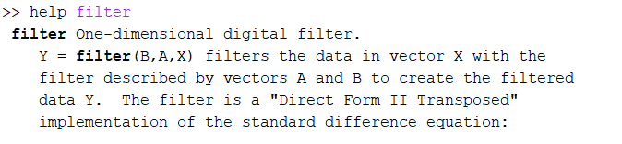
So in this way, the modiﬁed music can be heard after deciding the level of bass and treble i.e. by what amount the output needs to be scaled.

CODE:
NumLP = [0.0175366167041738,-0.00123208744075555,-0.00126915043548179,-0.00136025562557415,-0.00149366664105469,-0.00167080314533245……...];
NumHP = [-0.00361973788530617,-0.0143634165420230,0.00241061679918378,0.00129594079851364,0.00287581210907381,0.000662992036…..];

filename = 'C:\Users\AYUSHI\Downloads\Joeltrim (1).wav';
adata = filename;
adata = importdata(adata);
adata = struct2cell(adata);
fs = adata{2};
fs2 = fs;
info = audioinfo(filename);
info;

adata = cell2mat(adata(1,:));
soundsc(adata,44100);
pause(15);
while 1
%Taking the gain of Low pass filter
while 1
%Displaying dialogue box
LP = inputdlg('Gain of Low-Pass filter (bass amount, %) : (0 = disable)');
LP = str2double(LP{:}); %Converting string to number.
if ((LP < 0) || (LP > 100))
h4 = errordlg('Value must be between 0,100 !');
waitfor(h4);
else
break
end
end
while 1
%Displaying dialogue box
HP = inputdlg('Gain of High-Pass filter (treble amount, %) : (0 = disable)');
HP = str2double(HP{:});
if ((HP < 0) || (HP > 100))
h4 = errordlg('Value must be between 0,100 !');
waitfor(h4);
else
break
end
end
disp('Filtering ...');
pause(0.5);

%clearing all the variables except HP LP NumLP NumHP fs and fs2
clearvars -except LP HP adata audio fs NumLP NumHP fs2
audioHP = (HP/100)*filter(NumHP,1,adata);
audio = audioHP;

%clearing all the variables except HP LP NumLP NumHP fs and fs2
clearvars -except HP LP adata audio fs NumLP NumHP fs2
audioLP = (LP/100)*filter(NumLP,1,adata);
audio = audio + audioLP;

%If no bass and treble is given as input
if (audio == 0)
audio = adata;
else
disp('');
end

clearvars -except adata audio fs NumHP fs2
disp('Filtering complete.');

choice1 = menu('What would you like to do with your audio ?','Plot','Play','Plot & Play');
%Plotting the audio wave.
if (choice1 == 1)
plot(audio);
title('Audio Signal');
break
end
%Playing the audio wave.
if (choice1 == 2)
disp('Note : You can press CTRL + C to terminate the program and then type "clear playsnd" to stop the audio from playing.');
soundsc(audio,fs);
disp('Playing ...');
pause(length(audio)/fs)
disp('Playback over.');
break
end
%Plotting and Playing the audio wave.
if (choice1 == 3)
audio2 = audio;
disp('Note : You can press CTRL + C to terminate the program and then type "clear sound" to stop the audio from playing.');
soundsc(audio2,fs);
pause(0.1);
clear audio2
plot(audio);
title('Audio Signal');
pause(0.1);
disp('Playing ...');
pause(length(audio)/fs)
disp('Playback over.');
break
end
end

OBSERVATIONS:
TREBLED AUDIO SIGNAL OVERLAPPED OVER ORIGINAL AUDIO SIGNAL
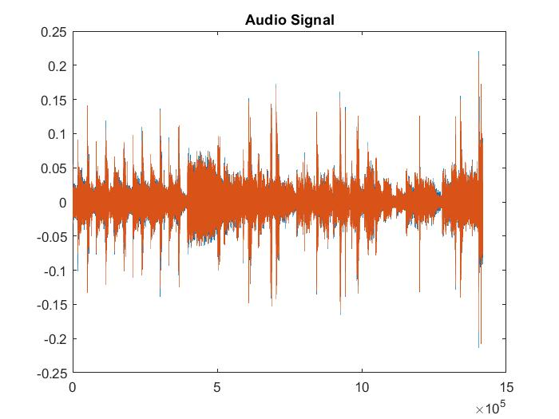
In treble the, we can observe that the lower frequency is attenuated and higher frequencies are boosted.

BASS BOOSTED SIGNAL OVERLAPPED OVER ORIGINAL AUDIO SIGNAL
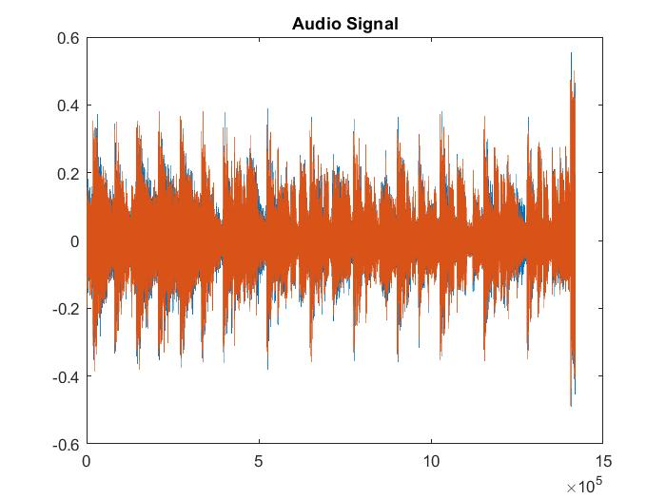
In Bass, we can observe that the higher frequency is attenuated and lower frequencies are boosted.

RESULTS AND CONCLUSIONS:

The challenge that we faced in EQ implementation is to ﬁnd suitable ﬁlters that will work well together in the required frequency ranges. The choice of correct ﬁlters, their ﬁlter coeﬃcients and the ranges in which these ﬁlters give the desired results were achieved by trying each of them during the implementation process, as well as making variations on the ranges of frequency.
We also went through each and every inbuilt function of the MatLab Documentation for executing the program. The Equalisation of the audio signal by designing Low pass and High pass filters is done successfully.

REFERENCES:
Mathworks MatLab Documentation
https://in.mathworks.com/help/comm/ug/equalization.html
https://www.digitaltrends.com/home-theater/eq-explainer/
https://en.wikipedia.org/wiki/Low-pass_filter
https://electronics.howstuffworks.com/how-to-understand-sound-equalizer.htm

